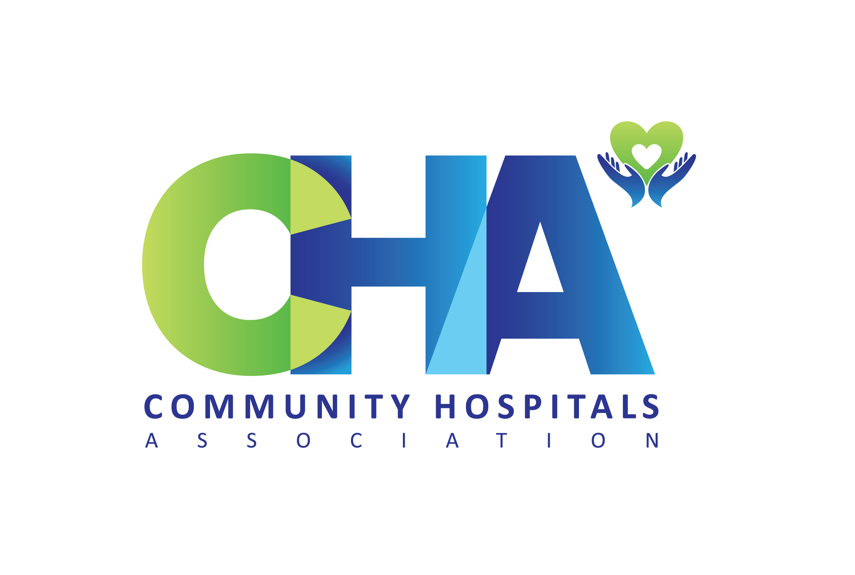

Community Hospitals Association

Community Hospital Special Interest Group within Q

Survey Analysis

The CHA SIG Project team carried out a survey of SIG members in order to assess whether the SIG was meeting its objectives, whether it was valued by members, and what suggestions could be made for on-going improvement. The survey was sent to all SIG members, who were invited to fill in an online survey on Google forms. There were two further prompts to encourage members to complete the survey. 13 SIG members replied.

Headlines

- SIG Benefit – sharing information with other SIG members
- SIG Page – useful particularly on discussion groups and outcomes
- SIG Discussion Groups – enjoyable, friendly, relaxed, informative
- SIG National Event – majority said they would attend
- SIG Future – widening membership

1. Benefits of Membership

We asked members what they hoped to get out of being a member of the CH SIG, and gave some suggestions. The responses showed in particular the value of sharing information and keeping up to date.

Share information with other SIG members (69%)
Keep up to date with CH developments (54%)
Learn about Community Hospital Quality Improvement (46%)
Meeting other members involved in community hospitals (46%)
Participate in online discussion groups (46%)
Contribute to growing network in Q involved in CH (39%)

Other (please specify)
Hear directly from SIG members about their experience and practice

2. SIG Page

Members completing the survey found the SIG page useful (92%). One respondent recorded a response of unsure. The respondent cited the inclusion on the SIG page of topics other than community hospitals which was described as distracting.

We asked for suggestions of what might be included on the SIG page in the future. Ideas included:

“More videos”
“More contributions from SIG members.”
“Perhaps more interaction from many members.”
“Snippets of the CHA SIG discussions, quotes from attendees.”

We asked respondents to say what was useful on the SIG page.

Notice of discussion groups and outcomes (70%)
Updates on community hospital studies (62%)
Resources in documents (46%)
Links to other members (30%)

3. SIG Discussions

All participating members had joined online SIG Discussions, and commented favourably. The most frequently used words are enjoyable, friendly, relaxed, informative.

“Yes they are useful.”
“Really stimulating discussions in relaxed way. Fascinating to hear about case studies and good practice.”
“There is a real enthusiasm and sharing of learning which even when not directly relevant to the work I am involved in is interesting, as well as areas I am directly interested in e.g. staff wellbeing.”
“Really enjoy them . Can't always make it but try to watch playback.”
“Accessible, friendly and great opportunity for sharing information.”
“Very informative and demonstration of hard work and good effort.”
“Love the zooms, great insights.”
“Really enjoyed meeting members from other disciplines.”
“Loads of activity illustrated.”
“Very welcoming and informative sessions.”

There was one view of disappointment with the content of some of the sessions.
“They have been of variable value to me, some offering real dissemination of useful info, others of less value. I thought safer staffing was particularly disappointing, lots of issues we know about but no clear solutions.”

We asked for ideas about future topics for Discussion Groups

Medicines Management
Frailty and Older People
Digital developments and emerging technology
Research
Local strategies for community hospitals
Using Community Hospitals as diagnostic centres and day/overnight surgical centres.
Staff wellbeing
How other community hospitals work / services provided/ staffing / general discussions
MIIU and/or UTC services
Social prescribing in community hospitals and hubs
Error and quality management
My preference is for practical content, ideas I could use
How to engage Government in realising what an asset CHs are and could be
Process Management and Quality Management

4. Networks

We asked if there would be interest in joining a specific network such as for Matrons or MACs (Meaningful Activities Coordinators). 2 members said that they would like to join a Matron network.

5. National Event
We asked if members would be interested in attending a National Event, and all but 2 said that they would.
6. What more would you like from the CH SIG
“More guidelines.”
“Looking forward to hearing from the range of staff in CH - MDT plus”
“Be good to have Leagues of Friends voice.”
“Be good to have Patient voice.”
“My interest is weaving between networks and sharing ideas.”
“Local networking meetings.”
“Joint projects with other SIGs.”

One respondent said that they did not want anything else at the moment.
“Nothing more than is provided at present. It can and will grow and evolve with its members.”

7. Membership of the CHA

9 respondents said that they were members of the CHA, and 4 said that they were not. Members of the Q SIG have been invited to join the CHA with a free personal lifetime membership.

Commentary by Convenors
The majority of the responses from SIG members were positive and encouraging.
SIG members have recorded that they value the Discussion Groups, and have suggested topics for the future programme. As Convenors, we have worked to incorporate many of these topics over the coming months.
SIG members value the information on the SIG page, and we will continue to populate it with news, events, Resource Packs etc.
There was limited support for joining specific CH networks such as Matrons, although this has been raised in discussions.
70% said that they would be prepared to attend a national event. We are grateful to Q & Q Connections for support for this in 2024, and the Q SIG Project team within the CHA has started to plan this.
The Community Hospital SIG contributes to sharing and learning on good practice and quality improvements. We appreciate that there is a need for a specific Community Hospital SIG. These small local hospitals are typically remote and rural. We want to support all those concerned with community hospitals, including staff, patients and communities.
We will consider the results of the survey and make changes and improvements as we can. We will repeat the survey in 2024.

Evelyn Prodger & Helen Tucker
September 2023

The CHA is pleased to be supported by the Health Foundation / Q Community

